EOC -Assembler

Anugrah Nambiar AM.EN.U4AIE21016

Q1.

Symbol less

1. MaxL.asm,

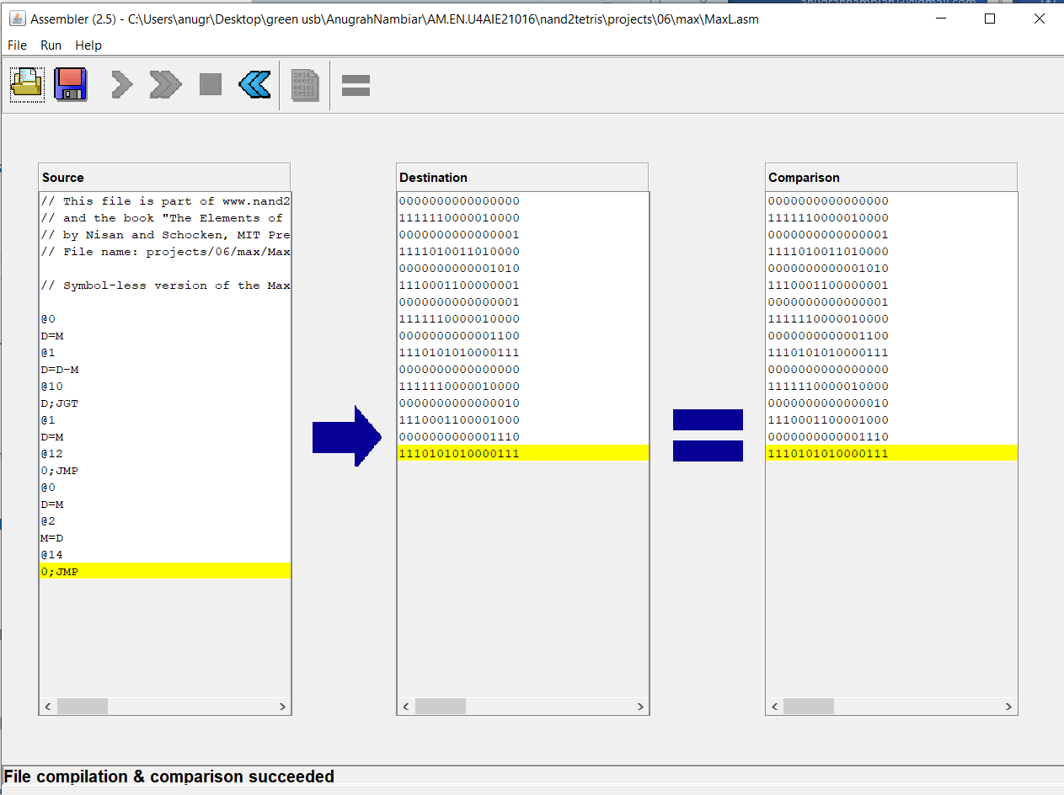

1. RectangleL.asm

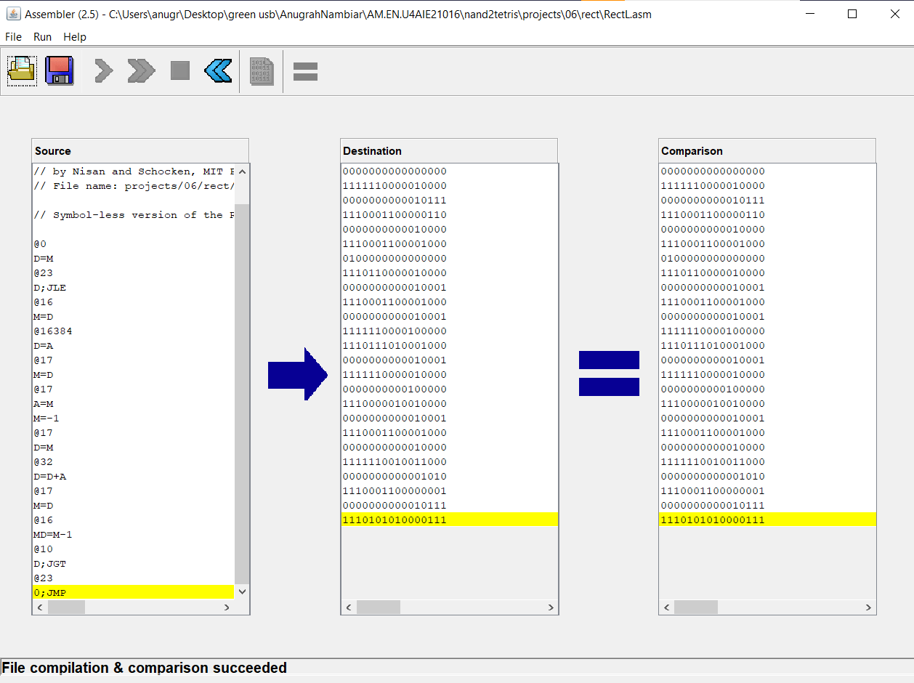

Symbol

a.Add

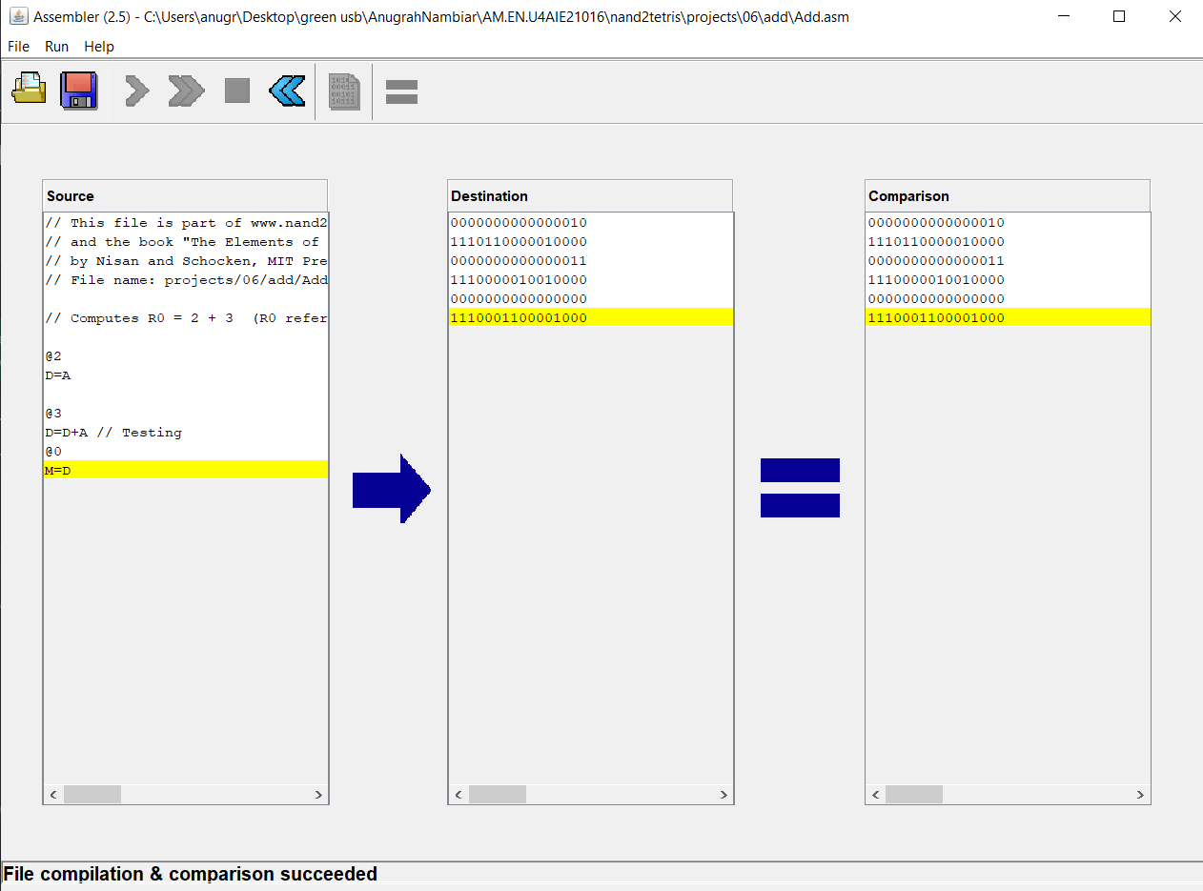

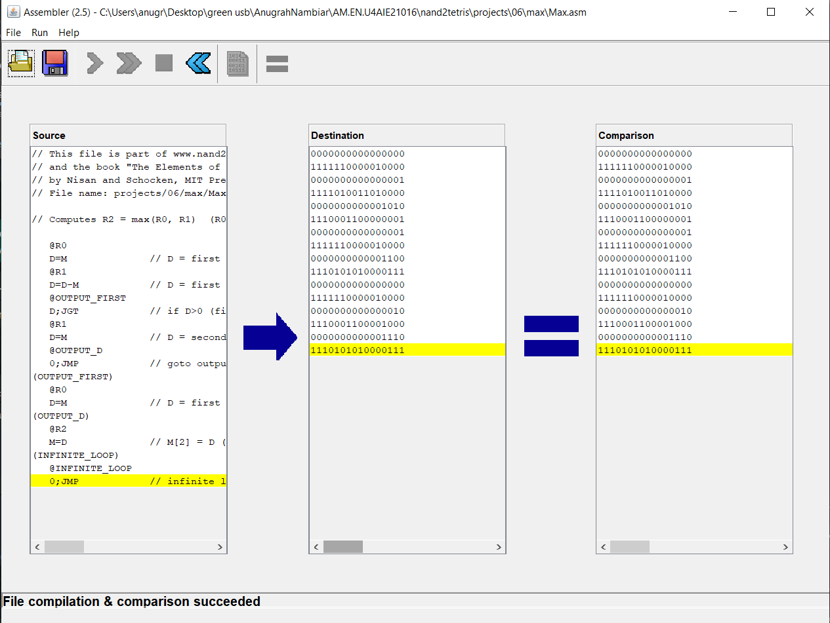b.Max

c.Rectangle